WHERE WERE YOU BORN?
The development of maternity services in
Brighton & Hove - told by the staff and mothers
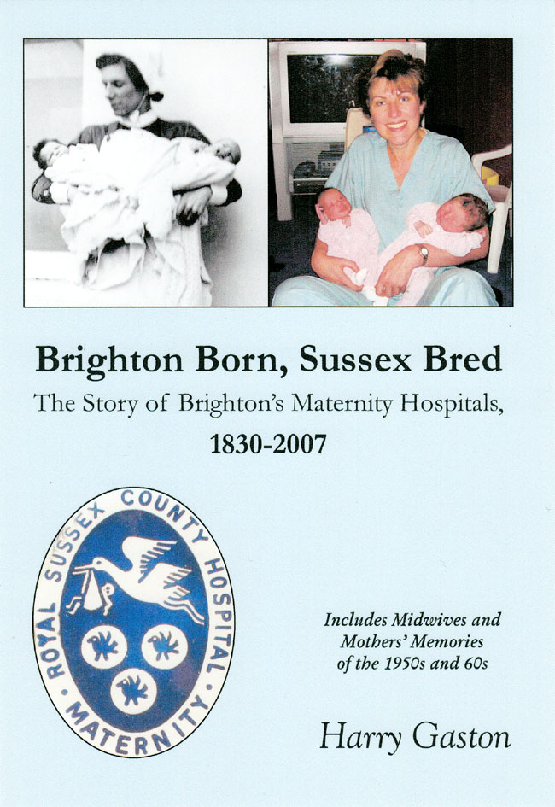 | Brighton Born, Sussex Bred  by Harry Gaston  Brighton Born, Sussex Bred shows how maternity care has developed over the last 200 years in Brighton & Hove and nationally.  Do you remember  Sussex Maternity Hospital?  Were you a Brighton General baby?  Fully illustrated, the book includes the experiences of mothers and midwives from the 1950’s to 1980’s as they tell their birth stories.
“A compelling read….detailed, comprehensive, and full of interest”
“Brighton Born, Sussex Bred”
A new book by local historian Harry Gaston
AN ORIGINAL GIFT – ORDER FORM OVERLEAF
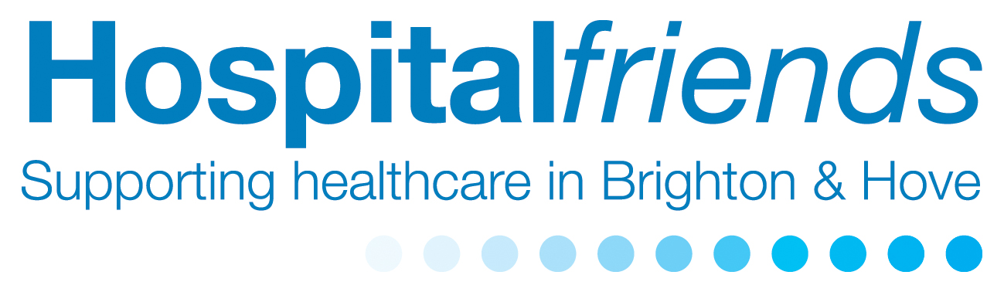
Order Form: “Brighton Born, Sussex Bred"
by Harry Gaston
No. of Copies: ……….at £12 per copy (includes UK P&P)
I also enclose a donation of: ………..... Total: ………………
(Cheques payable to Friends of Brighton and Hove Hospitals)
Name: ……………………………………………………………
Address: ………………………………………….………….….
Postcode: ……………..….. Tel: ………..……………………..
Email:…………………………………………………………….
Please return your order form to:
Friends of Brighton and Hove Hospitals,
37 St George’s Road, Brighton BN2 1ED
Tel: 01273 664936 E: hospitalfriends@lineone.net

Thanks to the generosity of the author, all proceeds from sales of the book will be used by Friends of Brighton and Hove Hospitals to benefit patients in Brighton and Hove.

